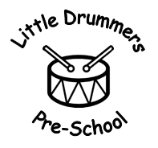
Little Drummers Pre-School
The Drummond Community Centre
Hedge End
SO30 2AD
02381 784187
littledrummerspre-school@hotmail.co.uk
Registered Charity No: 1020274

04. Health procedures
04.6 Oral health
The setting provides care for children and promotes health through promoting oral health and hygiene, encouraging healthy eating.
- Fresh drinking water is always available and easily accessible.
- Sugary drinks are not served.
- Children are offered healthy nutritious snacks with no added sugar.
- Parents are discouraged from sending in confectionary in their child’s lunch box.

Dummies
- Parents are advised to stop using dummies.
- Dummies that are damaged are disposed of and parents are told that this has happened.

Further guidance
Infant & Toddler Forum: Ten Steps for Healthy Toddlers www.infantandtoddlerforum.org/toddlers-to-preschool/healthy-eating/ten-steps-for-healthy-toddlers/

Adapted by- Kirsty Simpson Committee Chairperson
Position- Manager Emma Brisley
Sign- K.Simpson Sign- E.Brisley
Date- 31.01.24 Date- 31.01.24

